BIT 4107 – Mobile Application Development
ENHANCED PROFESSIONAL STUDENT LOGBOOK
Student Name: George Karema
Admission Number: BIT/2024/74385
School/Faculty: Computing and Informatics
Programme: Information Technology
Academic Year: 3rd
Semester: 2nd
Lecturer: Nyoro Michael
Phone Number: 0706498229

Instructions
This logbook is used to document weekly learning activities, practical exercises, skills acquired, challenges encountered, solutions applied, and reflections. Students should complete all sections every week.
Each week to follow remarks in week 1 section.
Contents
Instructions ii
Week 1: Introduction to Mobile Application Development iii
Practical Activities Undertaken iii
Tools/Software Used iii
Personal Reflection iv
Week 2: Mobile Development Environment v
Week 3: User Interface Design vi
Week 4: Event Handling and User Interaction ix
Week 5: Data Management xiii
Week 6: Networking and APIs xv
Week 7: Application Architecture xvi
Week 8: Project Planning xvii
Week 9: Device Features and Sensors xviii
Week 10: Notifications and Background Services xix
Week 11: Mobile Security xx
Week 12: Testing and Debugging xx
Week 13: Application Deployment xx
Week 14: Final Project Presentation xx
Semester Project Tracking xx
Project Objectives xxi
Project Requirements xxi
Development Milestones xxi
Testing Results xxi
Lessons Learned xxi
Future Improvements xxi
End of Semester Reflection xxii
Summary of Skills Acquired xxii
Most Interesting Topic xxii
Major Challenges Faced xxii
How Challenges Were Overcome xxii
Professional Growth Achieved xxii
Overall Course Experience xxii
Final Approval xxii

Week 1: Introduction to Mobile Application Development

Practical Activities Undertaken
only screenshots needed and labeling
Screenshots/Evidence Attached (Yes/No)

Tools/Software Used

Fig: 1.1: Android Studio
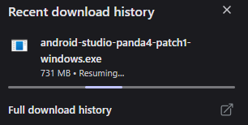
Fig 1.2 : Flutter
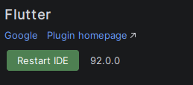

Fig:1.3: Stitch AI
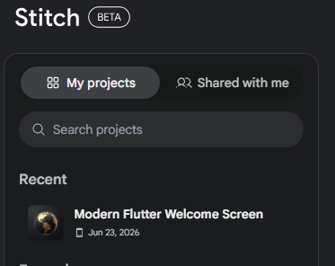

Personal Reflection
not more than 50 words
This project helped me understand how mobile applications integrate UI design, local storage, and API services. I gained practical experience in Flutter, SQLite CRUD operations, and REST API consumption. It improved my problem-solving skills, code organization, and understanding of real-world app development workflows

Week 2: Mobile Development Environment

Fig:2.1: Development Environment
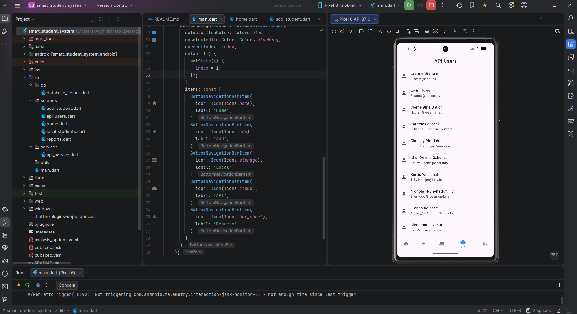

Week 3: User Interface Design
Fig 3.1: User interface week 1
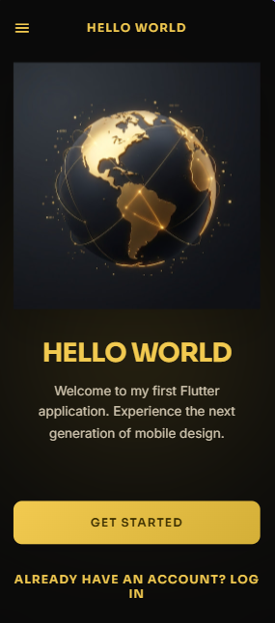
Fig 3.2: After clicking “Get Started” week 1
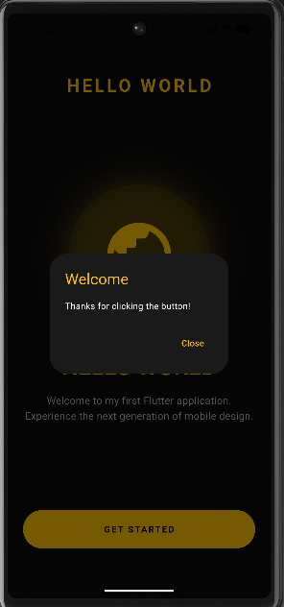
Fig 3.3: week 2 user interface
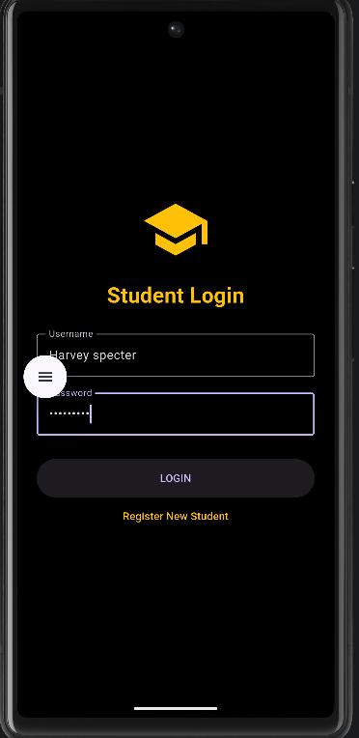
Fig 3.4: Week 3-7 user interface
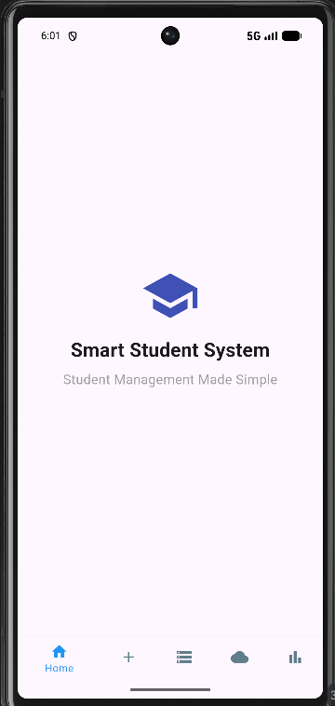

App Navigation week 3-7
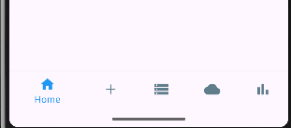

Week 4: Event Handling and User Interaction
fig 4.1: Add Students week 2
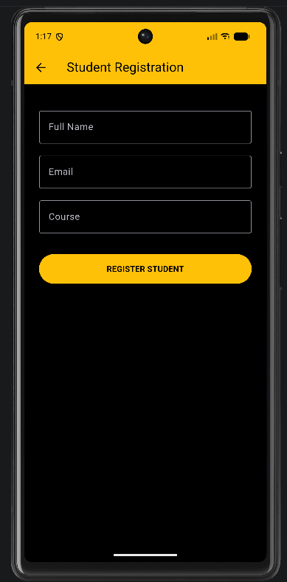

Fig 4.2: Add Students week 3-7
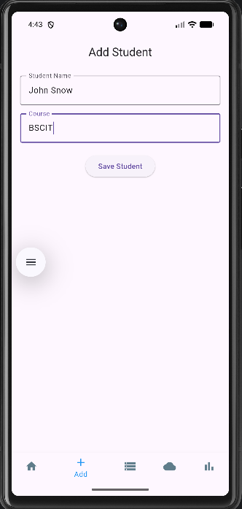
Fig 4.3: Saved student Week 2
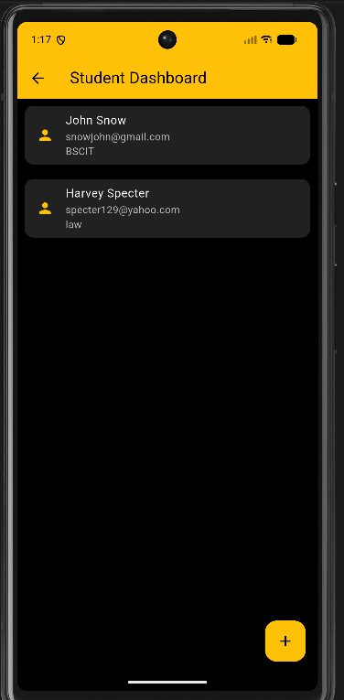
Fig 4.4: Saved student successful message Week 3-7
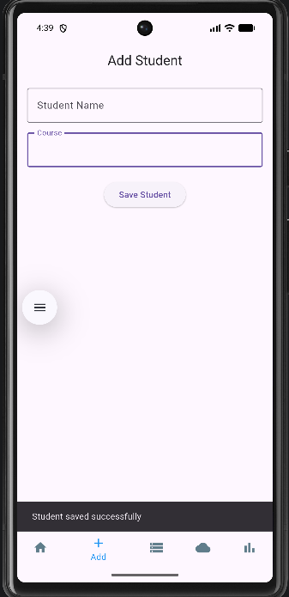
Fig 4.5: : Saved student Week 3-7
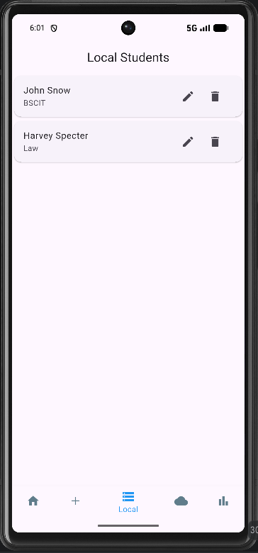
Fig 4.6: Delete Students Week 3-7
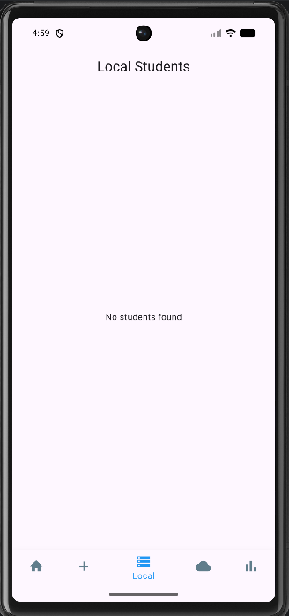

Week 5: Data Management
Fig 5.1: Local Storage SQLite database week 3-7

Fig 5.2: Update Student’s Info week 3-7
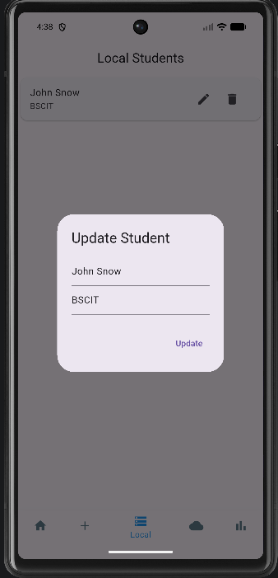
Fig 5.3: Delete Students week 3-7

Fig 5.4: APIs week 3-7
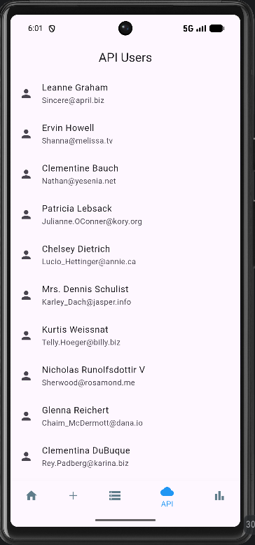

Week 6: Networking and APIs
Fig 6.1: API User Screen -HTTP GET
-JSON data display


Week 7: Application Architecture
Fig 7.1: Application Architecture
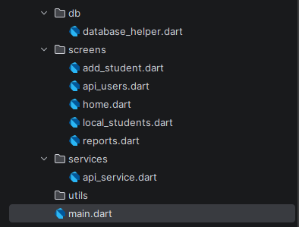

Week 8: Project Planning

Week 9: Device Features and Sensors

Week 10: Notifications and Background Services

Week 11: Mobile Security

Week 12: Testing and Debugging

Week 13: Application Deployment

Week 14: Final Project Presentation

Semester Project Tracking

Project Objectives

Project Requirements

Development Milestones

Testing Results

Lessons Learned

Future Improvements

End of Semester Reflection

Summary of Skills Acquired

Most Interesting Topic

Major Challenges Faced

How Challenges Were Overcome

Professional Growth Achieved

Overall Course Experience

Final Approval
Student Name: __________________________
Student Signature: ______________________
Date: _________________________________
Lecturer Name: _________________________
Lecturer Remarks: _____________________
Date: _________________________________

